A WEB-BASED VEHICLE COMPLIANCE SYSTEM FOR IMPROVING ROAD SAFETY IN KENYA

191351

167298

A Project Proposal Submitted to the School of Computing and Engineering Sciences
In Partial Fulfilment of the Requirements for the Award of the Degree of
Bachelor of Business Information Technology (BBIT)

School of Computing and Engineering Sciences
Nairobi, Kenya

July 2026
DECLARATION
We declare that this project proposal is our original work and has not been submitted to any other institution for academic credit.

Student Name: Estelle Joy Nyawira Gatiti
Admission Number: 191351
Student Signature: _______________________ Date: _______________________

Student Name: Jemima Thadeus Moye
Admission Number: 167298
Student Signature: _______________________ Date: _______________________

Supervisor Name: Cythnia Mkabane
Supervisor Signature: _____________________Date: _______________________

ABSTRACT
Traffic accidents in Kenya, particularly in the city of Nairobi, are predicted to continue to pose a major threat to the country’s public safety owing to traffic congestion, overspeeding, and poor enforcement of traffic rules. The main problem is likely to be the non-real-time vehicle compliance checking process, whereby different systems are used to verify driving licence, insurance coverage, and vehicle registration independently of each other. This will make it easy for vehicles that fail to meet the required standards to use public roads, making them more prone to accidents and, therefore, injuries, deaths, and economic losses to individuals, hospitals, and even the country at large. Despite various efforts aimed at addressing the issue, including the enactment of the Traffic Act and NTSA solutions such as the TIMS system and insurance rules, compliance checking will largely depend on manual processes. To bridge these research gaps, the proposed study aims to develop an integrated vehicle compliance verification system via the web. This would incorporate insurance, licensing, registration, and servicing documents of vehicles in one system. The law enforcement agents would be able to easily verify compliance status by using the number plate of the vehicle, while citizens and administration would be able to manage compliance information on the web. For this development, the Modified Waterfall model would be used, where, after requirement analysis, object-oriented design would take place, followed by implementation through HTML, CSS, JavaScript, and PHP and finally structured testing.

TABLE OF CONTENTS
DECLARATION ii
ABSTRACT iii
TABLE OF CONTENTS iv
LIST OF FIGURES vi
LIST OF ABBREVIATIONS vii
1 Chapter 1: Introduction 1
1.1 Background 1
1.2 Problem Statement 2
1.3 General Objectives 3
1.4 Specific Objectives 3
1.5 Justification 4
1.6 The Scope 4
1.7 Limitation and Delimitation 5
2 Chapter 2: Literature Review 6
2.1 Introduction 6
2.2 The current vehicle compliance verification processes, regulations, and systems used in road safety management. 6
2.1.1 Vehicle Compliance Data Collection Process 7
2.1.2 Guiding Rules and Regulations for Vehicle Compliance 7
2.3 Challenges in Vehicle Compliance Verification Systems 8
2.4 Review of Existing Systems 10
2.4.1 Transport Integrated Management System (TIMS) 10
2.4.2 Electronic National Traffic Information System (eNaTIS) — South Africa 11
2.4.3 Insurance Regulatory Authority Online Portal (IRA) 13
2.5 Conceptual Framework 14
3 Chapter 3: Methodology 16
3.1 Introduction 16
3.2 Project Orientation 16
3.3 Methodology 16
3.3.1 Requirements Analysis 18
3.3.2 Analysis and Design 18
3.3.3 Development 19
3.3.4 Testing 19
3.4 Deliverables 19
4 Chapter 4 System Analysis and Design 21
4.1 Introduction 21
4.2 System Requirements 21
4.2.1 Functional Requirements 21
4.2.2 Non-Functional Requirements 22
4.3 System Analysis Diagrams 23
4.3.1 Use Case 23
4.3.2 Sequence Diagram 24
4.3.3 Entity Relationship Diagram 29
4.3.4 Class Diagram 30
4.3.5 Database Schema 31
4.3.6 Wireframe Diagram 32
References: 33

LIST OF FIGURES

Figure ‎2.1 NTSA TIMS Dashboard Interface Showing Driver and Vehicle Services 11
Figure ‎2.2 NaTIS Website 13
Figure ‎2.3 IRA Dashboard 14
Figure ‎2.4 Conceptual Framework for the Proposed Vehicle Compliance Web Application 15
Figure ‎3.1 The Waterfall Model of the Software Development Lifecycle 17

LIST OF ABBREVIATIONS

AARTO – Administrative Adjudication of Road Traffic Offences
AKI – Association of Kenya Insurers
API – Application Programming Interface
CSS – Cascading Style Sheets
DDL – Digital Driver Licence
eCitizen – Electronic Citizen Portal
e-DL – Electronic Driver’s Licence
eNaTIS – Electronic National Traffic Information System
ERS – Entity Reporting System
GDP – Gross Domestic Product
HTML – HyperText Markup Language
IAIS – International Association of Insurance Supervisors
IRA – Insurance Regulatory Authority
ITS – Intelligent Transport Systems
KCB – Kenya Commercial Bank
KRA – Kenya Revenue Authority
NTSA – National Transport and Safety Authority
OOAD – Object-Oriented Analysis and Design
OTP – One-Time Password
PHP – Hypertext Preprocessor
PIN – Personal Identification Number
PSV – Public Service Vehicle
RBS – Risk-Based Supervision
SABS – South African Bureau of Standards
SDG – Sustainable Development Goal
SOA – Service-Oriented Architecture
TIMS – Transport Integrated Management System
WHO – World Health Organization

Chapter 1: Introduction

Background
Road accidents continue to pose serious public safety issues in Kenya, especially in cities like Nairobi, owing to heavy traffic, over speeding, and a lack of road discipline, among other factors. Examples of roads that have continued to witness many accident cases include the Thika Superhighway (Karoki et al., 2025). This implies that there are problems with the current measures taken to curb such accidents. The primary cause of accidents on the roads involves vehicles that fail to comply with certain regulations, such as those running without insurance policies, valid driving licences, or even without necessary registration. Road accident incidents have continued to be high. According to NTSA, Kenya recorded 4,748 road fatalities in 2024, with Nairobi accounting for the highest number of deaths (2024 Year of Carnage as 4,700 Killed on Roads, n.d.). Although it is said that reckless driving and bad road networks are the major causes of road accidents, it is clear from the various studies conducted that non-compliance worsens accidents.
The impact of road accidents is prevalent throughout all individuals, families, and governmental institutions. Pedestrians are one of the most susceptible road users due to their greater probability of sustaining severe injuries during accidents. The absence of insurance coverage or registration in cases of accidents poses a challenge to receiving adequate compensation for accident victims, causing the family members to bear costs associated with hospitalisation, rehabilitation services, or loss of employment. Road accidents do not just affect the lives of individuals; instead, they pose barriers to productivity and economic challenges on the national level, particularly in developing nations experiencing high accident incidence rates. Furthermore, according to reports from the Insurance Regulatory Authority (IRA), the number of fraudulent claims relating to insurance is rising (Karoki et al., 2025)found that pedestrians using the Thika Superhighway are highly exposed to traffic accident dangers due to non-compliant vehicles.
As a solution to this problem, the Kenyan government has initiated legislation that seeks to improve the compliance rate and minimise accidents. Among others, there is the Traffic Act that ensures compliance by stipulating that all vehicle owners and drivers must observe legal responsibilities. Past interventions, for instance, the implementation of the Michuki Rules that mandated Public Service Vehicles (PSV) to fit speed limiters, seat belts, observe passenger capacities, and uniform dressing, among others, have played a key role in instilling discipline in the transportation sector with minimal road accidents (Wamwea, 2023). Despite these steps, enforcement has become weak over time. According to (Onyango, 2022), manual verification at checkpoints remains slow and prone to corruption, allowing non-compliant vehicles to bypass enforcement. The current compliance measures are inadequate due to the independent nature of the processes involved in ensuring compliance. Compliance measures, including licensing, insurance verification, and vehicle registration, involve different systems that cannot be coordinated when it comes to roadside enforcement, where quick responses are needed (Terefe et al., 2025).
This research aims to fill the identified gaps through the development of a unified online vehicle compliance tool that combines insurance, licensing, and vehicle registration databases into one database. This ensured that enforcement officials were able to check compliance through the number plate of the vehicle instantaneously, without having to physically examine documents, which can be fraudulent and delay verification. Studies show that unified compliance systems are efficient in ensuring enforcement activities since they make verification more efficient and require shorter times. Additionally, the proposed compliance system contained vehicle compliance information to assist in ensuring the roadworthiness of vehicles. This approach helped reduce non-compliance instances, increase accountability, and improve road safety in Kenya (Organization, 2023).

Problem Statement
The lack of real-time vehicle compliance is a major challenge that negatively affects road safety in Kenya. Although mechanisms exist to verify insurance certificates, driving licences, and vehicle registration, there might not be a proper linkage, hence making it hard to carry out the compliance instantly. The enforcement officers must therefore use manual methods or online systems offered by authorities such as the NTSA to ensure the entire process is carried out, something that makes it prone to mistakes. This challenge creates opportunities whereby unauthorised vehicles can access roads despite not having the relevant documents. As a result, both unauthorised drivers and unsafe vehicles have contributed to increased road accidents in the region. Injuries from road traffic accidents constitute over 90% of total deaths caused by road traffic accidents in developing countries such as Kenya. Road traffic injuries are reported to be the leading cause of death across the globe, according to the (Global Status Report on Road Safety 2023, n.d.).
It is the absence of such an elaborate system of compliance that makes the problem worse, since this has rendered the whole process ineffective. This is because it would be hard for the police to determine if the car satisfies the required standards. There is no single point in which all the information on car compliance would be gathered. It means that the whole process becomes passive rather than proactive, as it consumes a considerable amount of time. Therefore, the risk of accidents on the road increases. Furthermore, such accidents can prove very expensive to the economy of a country, as they lead to higher health costs, production losses, and damage to the road infrastructure. The World Bank estimates that road accidents cost countries 3% of their GDP every year (World Development Report 2020, 2020). This research aligns with Sustainable Development Goal 3.6 (halving road traffic deaths by 2030), SDG 11.2 (safe transport systems), and Kenya Vision 2030.

General Objectives
To design and develop a web-based application to facilitate vehicle compliance verification and improve road safety management.

Specific Objectives
- To examine the current vehicle compliance verification processes, regulations, and systems used in road safety management.
- To analyse the challenges and limitations of existing systems in detecting and managing non-compliant vehicles.
- To design a web-based system that integrates vehicle, insurance, license, and service records for real-time compliance verification.
- To develop the proposed system using appropriate technologies to support efficient data access and user interaction.
- To test and evaluate the system to ensure it meets the required functionality, usability, and performance standards.

Justification
Not only will the suggested web-based application assist law enforcement agents in verifying the compliance status of vehicles quickly, but other interested parties, including government officials, insurance firms, and citizens, will gain from this initiative. The web-based application will facilitate quick identification of non-compliant vehicles, as the application will have all necessary information about the vehicle and its compliance status. This will minimise the risk of accidents that result from non-compliant drivers and vehicles because the roads will be safer (Zhong et al., 2025). The application will enable vehicle owners to keep track of their vehicle compliance status, which will prompt them to rectify any problems at an earlier stage.
Government agencies like the NTSA would benefit from this since it would be easier for them to monitor and enforce the safety regulations in place on the roads. With reduced accidents, there will be less strain on the hospitals and economic costs as well, since less damage will be incurred. There is also the possibility of benefit for insurance companies as they could have an easier time confirming their records. There are future benefits in terms of establishing safer and more orderly transport systems as well. Onyango confirms that manual verification processes at Kenyan checkpoints are slow and vulnerable to corruption, highlighting the need for an automated, integrated solution (Onyango, 2022).

The Scope
The proposed research is mainly concerned with the design and development of a prototype of a web-based vehicle compliance checking system, with its target audience being three key stakeholders, such as the citizens who own or use a vehicle, the traffic police, and system administrators in charge of maintaining compliance records. There will be three main compliance criteria covered by the system: the validity of the vehicle insurance, the condition of the driver's license, and vehicle registration, with vehicle service history forming a fourth criterion (Organisation, 2023). The research is tied to a prototype framework, which means that there is no way of integrating the project with actual government systems like the NTSA TIMS database, AKI insurance portal, and the IRA regulations framework, since such an initiative would be beyond the mandate of any academic research project. The framework will have no capability for dealing with the renewal processes for vehicles, paying for services, developing mobile applications, and implementing the system on a national level, among other tasks. It will have no applicability to commercial vehicles, public service vehicles, and other transport modes whose frameworks are different from those used by regular passenger vehicles. Geographically, the research problem is drawn from the highly populated road network in Nairobi, mainly the Thika superhighway.

Limitation and Delimitation
The deployment of the proposed compliance checking system is hindered by the limited ability to use live government databases, such as the ones maintained by the National Transport and Safety Authority (NTSA), due to which it is not possible for the system to interact with real-time data regarding vehicle registration, licensing, and insurance status. The use of internally generated simulation data sets in place of live data sets will ensure that the functionality of the system can be proved.

Chapter 2: Literature Review

Introduction
This chapter reviews relevant literature about vehicle compliance verification systems. This is done by describing how compliance procedures, such as those related to insurance, licensing, and registration, are undertaken. The chapter analyses the responsibilities of various stakeholders within the process of enforcing road safety laws. In addition, the chapter describes the data gathering processes that facilitate vehicle compliance verification. Furthermore, the regulations governing vehicle compliance verification are examined. Also, the chapter analyses various challenges that are associated with vehicle compliance verification, which include fragmented processes and manual compliance verification. Various existing systems that facilitate vehicle compliance verification, such as T.I.M.S. and E.N.A.T.I.S., are reviewed.

The current vehicle compliance verification processes, regulations, and systems used in road safety management.
Vehicle enforcement compliance verification helps promote road safety. In the verification process, one needs to verify matters such as insurance, licensing, and vehicle registration. Through verification, one verifies if vehicles comply with regulatory standards. The compliance verification process regulates the transportation system in Kenya through the National Transport and Safety Authority. However, this process is usually carried out manually (Onyango, 2022).
Various tasks fall under the ambit of the compliance process. This includes collecting information from both insurance and license companies. It also includes roadside verification conducted by traffic officers. According to research, fragmented systems are inefficient (Onyango, 2022). Researchers have pointed out the need for integrating digital verification systems. The systems that exist currently function individually within various government departments. This affects the timeliness of information related to compliance (Adisa & Eludiora, 2021).
Various parties play roles in compliance verification activities. The parties include government authorities, insurance firms, car owners, and law enforcers. All parties have their data management systems for managing data regarding compliance separately. Lack of coordination between the different parties results in inefficiency in enforcement activities. Studies indicate that integrated systems enhance accountability and transparency. According to the World Health Organisation, strict enforcement is critical in enhancing road safety. However, present systems do not offer full integration(Organisation, 2023).

Vehicle Compliance Data Collection Process
The process of collecting data for vehicle compliance includes acquiring data from various sources. Insurance firms, licensing authorities, and registration files are some of the sources of data. Data collection serves to confirm that the vehicle is legal on the road. Verification of documentation is done manually by the law enforcers at checkpoints. The National Transport and Safety Authority takes responsibility for vehicle registration and compliance data. Nonetheless, systems are not well integrated in real-time (Onyango, 2022).
Data collection methods used traditionally have been mainly manual. The officers depend on documents provided by the drivers. It gives room for forging and misleading information on the document. According to the literature, manual checks have been found to cause many mistakes during enforcement. Electronic means are available, but they are not completely integrated across various organisations. The need for a system for data collection is emphasised. Complete integration reduces mistakes and speeds up the verification process (Segui-Gomez et al., 2025).
Vehicle compliance information can be gathered through official and unofficial sources. Examples of official sources are government databases and insurance companies. Examples of unofficial sources are manual reporting mechanisms and roadside inspections. Standardisation issues have an impact on the quality of the data collected. Studies have found that fragmented database systems are responsible for poor results in enforcement operations (Onyango, 2022).

Guiding Rules and Regulations for Vehicle Compliance
Compliance for vehicles in Kenya is regulated through strict legal statutes. For instance, the Traffic Act provides for the licensing of motor insurance and the registration of vehicles. Compliance with such measures ensures that all vehicles are accountable and compliant with traffic regulations in the country. Compliance with the above measures is monitored by the National Transport and Safety Authority.

According to the WHO, there should be strict enforcement of traffic laws. Compliance ensures safety in the community and minimises the chances of accidents. The international standards have indicated that integrated digital traffic law enforcement is important. Integrated enforcement helps in minimising corruption activities, but many developing nations encounter problems when implementing such regulations. There is a case for Kenya (Muguro et al., 2024).

There are existing laws that stipulate the need for proper coordination among the agencies responsible for the enforcement of the said laws. Unfortunately, there are separate stand-alone systems implemented by each agency that are not interconnected. As such, the validation process cannot be done instantly in the enforcement process. The officers manually check the documents, which will slow down the process and make human errors more prone (Towers, 2024).

2.3 Challenges in Vehicle Compliance Verification Systems
There are several major flaws with the process of verifying the compliance status of vehicles in Kenya. Perhaps the most crucial one lies in the separation of the systems controlling the vehicle insurance, driver license issuance, and vehicle registration databases. The former two belong to the National Transport and Safety Authority, while the latter belongs to the Insurance Regulatory Authority, and they function independently from each other. There are several reasons behind such a situation, starting from institutional barriers, the use of incompatible information systems, and up to the absence of a coherent technological infrastructure. Thus, law enforcers are not able to check all aspects at once, which results in inefficiency. Studies reveal that fragmented information systems lead to low operational performance and raise the risk of fraud (Onyango, 2022).
Manual and document-based verification systems form another weakness that exists. At roadside checks, manual and document-based verification are done, whereby there is the use of physical documentation like insurance cards and driver’s licences. The main challenge with these systems is that they are prone to forgery, expiry, and duplication. This weakness results from the lack of technology usage and integration in the systems. Studies show that manual verification increases the chances of corruption and slows down the whole process (Adisa & Eludiora, 2021). With these weaknesses, non-compliant vehicles remain operational on the roads.
This poses a big challenge within the transport industry and the entire system at large. Weak verification makes it easy for those without a driving license and those who are not insured or registered to access the roads without any problem. The World Health Organisation notes weak enforcement of road safety regulations as the leading cause of road traffic accidents in developing nations. In addition, accidents caused by uninsured people make it impossible for the affected persons to get compensated for their medical bills and property damage. Economically, the nation suffers losses in terms of loss of productivity due to deaths and other expenses that come about from such accidents (Segui-Gomez et al., 2025).
Several attempts have been made over time to tackle these challenges. For instance, the government of Kenya has developed digital tools like Transport Integrated Management System (TIMS) and eCitizen portals to facilitate better registration of vehicles and the issuance process of driver's licenses. This move has minimised bureaucracy and facilitated easy accessibility to services by users. Nevertheless, according to research, these measures have not effectively tackled the problem since they lack interlinkage in a real-time manner (Segui-Gomez et al., 2025). In other words, while these digital measures are a good sign of embracing digital transformation, they have not completely solved the main problem at hand.
However, there still seems to be considerable room for improvement despite all this. Currently, the systems employed do not offer an integrated platform that can enable the enforcement agents to easily check the insurance, license, and registration of any car instantly. Therefore, in essence, the process of enforcing road safety remains largely dependent on the actions of the enforcement officers. Several studies have shown that the use of information systems helps improve the efficiency of the enforcement process and decision-making, and helps in reducing the level of fraud in society (Wagle & Dahal, 2025).
Towards addressing such shortcomings, this paper seeks to propose an online compliance verification system, which incorporates data from vehicle insurance, drivers' licenses, and vehicle registrations. It will make it possible for real-time verification through the use of the vehicle's number plate. Research proves that such systems are more effective since they cut down on verification time. (Adisa & Eludiora, 2021). In solving some of the shortcomings of the existing systems, the proposed solution will help in boosting the mechanisms for enforcing traffic rules in Kenya, thus ensuring safety on the roads.

2.4 Review of Existing Systems

2.4.1 Transport Integrated Management System (TIMS)
Transport Integrated Management System (TIMS) is a web application created by the NTSA, Kenya. The TIMS system integrates all transport services, including vehicle registration, vehicle inspections, public transport operations, management of driving schools, driver testing, and licenses on a single platform. In January 2024, the full transition of all transport services offered through the TIMS portal to the national eCitizen portal serviceportal.ntsa.go.ke was done. eCitizen(Muguro et al., 2024)
How the System Works to Address the Problem. The TIMS system computerises and centralises the administration of transport in Kenya, allowing citizens to carry out transactions without going to NTSA offices physically. Some of its functions include the registration of motor vehicles and issuing of log books, change of ownership, verification of PSV badge, checking whether the vehicle has been inspected, and processing of driving licences. The enforcement personnel may also use a number plate to search for motor vehicle records (Atianashie Miracle, 2023).
Tools and Technologies Utilised. TIMS operates using a web-based architecture that is embedded within the eCitizen platform and uses two-factor authentication, one-time password verification, and KRA PINs to facilitate logins (Alotaibi et al., 2023). Payments are made using the M-Pesa method, bank cards, and bank transfers. The upgrade of the data centre in 2024 by Vertiv resolved the issue of 60,000 applications in the pipeline backlog and enhanced the license registration process to 80,000 per month.
New Technologies. One emerging technology is the second-generation smart driver’s license (e-DL), whose development involves a Public-Private Partnership with KCB Bank and Pesa Print Limited. The e-DL will interact with TIMS and, more importantly, with insurance and inspection databases, which will allow the police to check the vehicle’s insurance coverage, inspection records, and license validation via mobile devices at the roadblocks(Kodiyatar & Shamala, n.d.). How Effectively Does It Meet the Challenge? In terms of effectiveness, TIMS increased transparency and cut the transaction period as well as document fraud. The inclusion of TIMS in the eCitizen platform reflects good governance, and a study showed that SOA integration increased its system usability from 77.5 to 87.5.
Challenges, Gaps, and Inefficiencies. There is no integrated user interface in TIMS that allows an officer to check insurance, licence, and registration at the same time. Insurance validation is still outside TIMS and managed by the IRA independently of NTSA, without any real-time information exchange (Onyango, 2022). This implies that the officer needs to access more than one database to ascertain whether there are no outstanding payments from a vehicle owner. The improved functionalities for the e-DL are still under development as of early 2026.

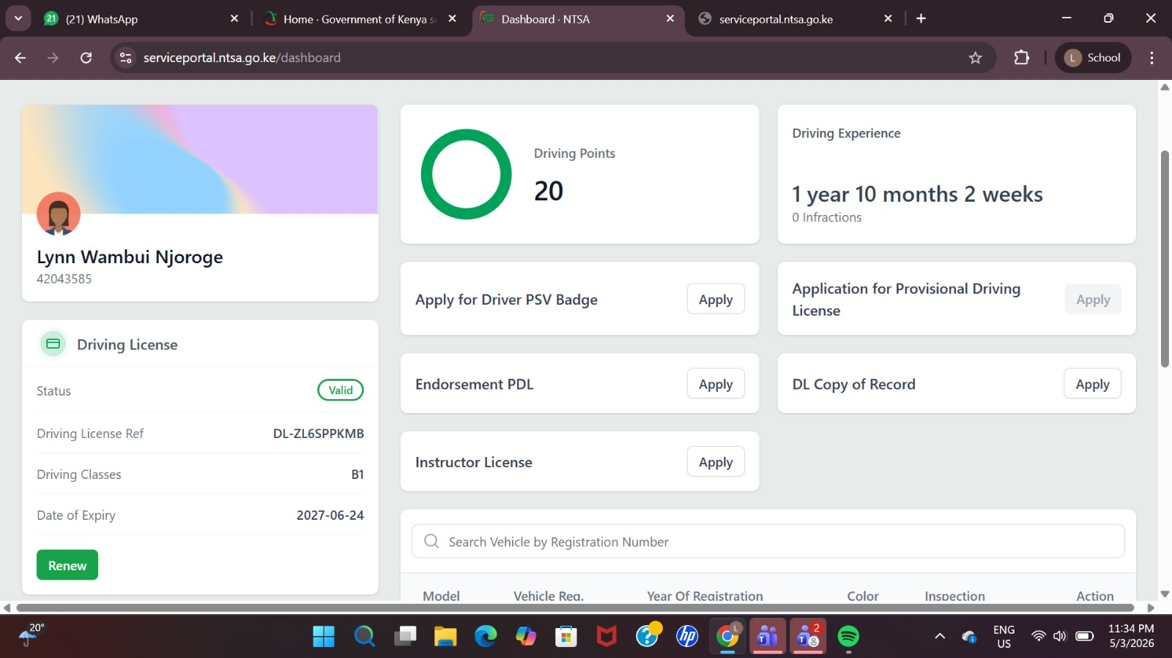
Figure ‎2.1 NTSA TIMS Dashboard Interface Showing Driver and Vehicle Services

2.4.2 Electronic National Traffic Information System (eNaTIS) — South Africa
In the early 2000s, South Africa had an outdated, technologically deficient traffic information system that could not cope with rapid road development and the growing number of vehicles. The solution came through the creation of the Electronic National Traffic Information System (eNaTIS), which was implemented in 2007 as a replacement for the outdated NaTIS system, which had developed serious technical flaws since its implementation almost 14 years ago. Currently, the eNaTIS serves as a national register for all registered vehicles, drivers, and other traffic information in South Africa, aiding police forces in monitoring adherence to traffic laws. eNaTIS operates from more than 1,753 sites around the country, managing 40,000 transactions per hour worth of R3 billion annually.
One reason that eNaTIS is particularly appropriate for this investigation is its comprehensive nature of integrating compliance into a unified system. Instead of treating issues of vehicle registration, driver licensing, and traffic law enforcement independently, eNaTIS integrates all three into one national database. Field officers employ a hand-held battery-powered law enforcement terminal that provides immediate information about any false licences and any vehicles that are not registered during roadblocks (Towers, 2024). Furthermore, the software connects with the South African Bureau of Standards (SABS) to ensure that only vehicles which meet national safety standards are allowed to be registered. (SABS Website, n.d.). As part of a broader strategy to prevent document fraud, eNaTIS instituted electronic tagging of face value documents like licence cards and registration certificates, as well as fingerprint biometric identification for driver identity verification. Lastly, the integrated automated roadside traffic offender demerit points system, known as AARTO, monitors driver behaviour, rewarding and penalising them with points for road violations. Thus, eNaTIS follows the worldwide trend towards ITS technology.
As far as African traffic control is concerned, the benchmark for eNaTIS has certainly been set. The magnitude of its implementation and its real-time enforcement capacity exemplify precisely what Kenya needs to do, namely, to achieve unity of regulation (SABS Website, n.d.). The very existence of an eNaTIS-type project in Africa is evidence enough that the problems can indeed be addressed.
However, even eNaTIS is yet to fully close the loop; insurance verification is not within its real-time remit, as mandatory insurance through the Road Accident Fund levy is part of vehicle licensing, but optional comprehensive insurance verification is outside of the system, reflecting a similar fragmented nature identified in the case of Kenya. (Demerit System, AARTO and Driver Behaviour, n.d.). Indeed, the system has had issues of service outage and data quality with regard to outdated data on vehicles and drivers. Most importantly, perhaps, the eNaTIS architecture, built in the mid-2000s, increasingly feels dated in an era of cloud-based computing, real-time API integration and mobile-first systems. These shortcomings are telling in that even advanced integrated traffic management systems in Africa remain lacking in terms of unified and real-time agency-wide compliance verification, the very gap that the proposed solution for this study aims to fill (Onyango, 2022).

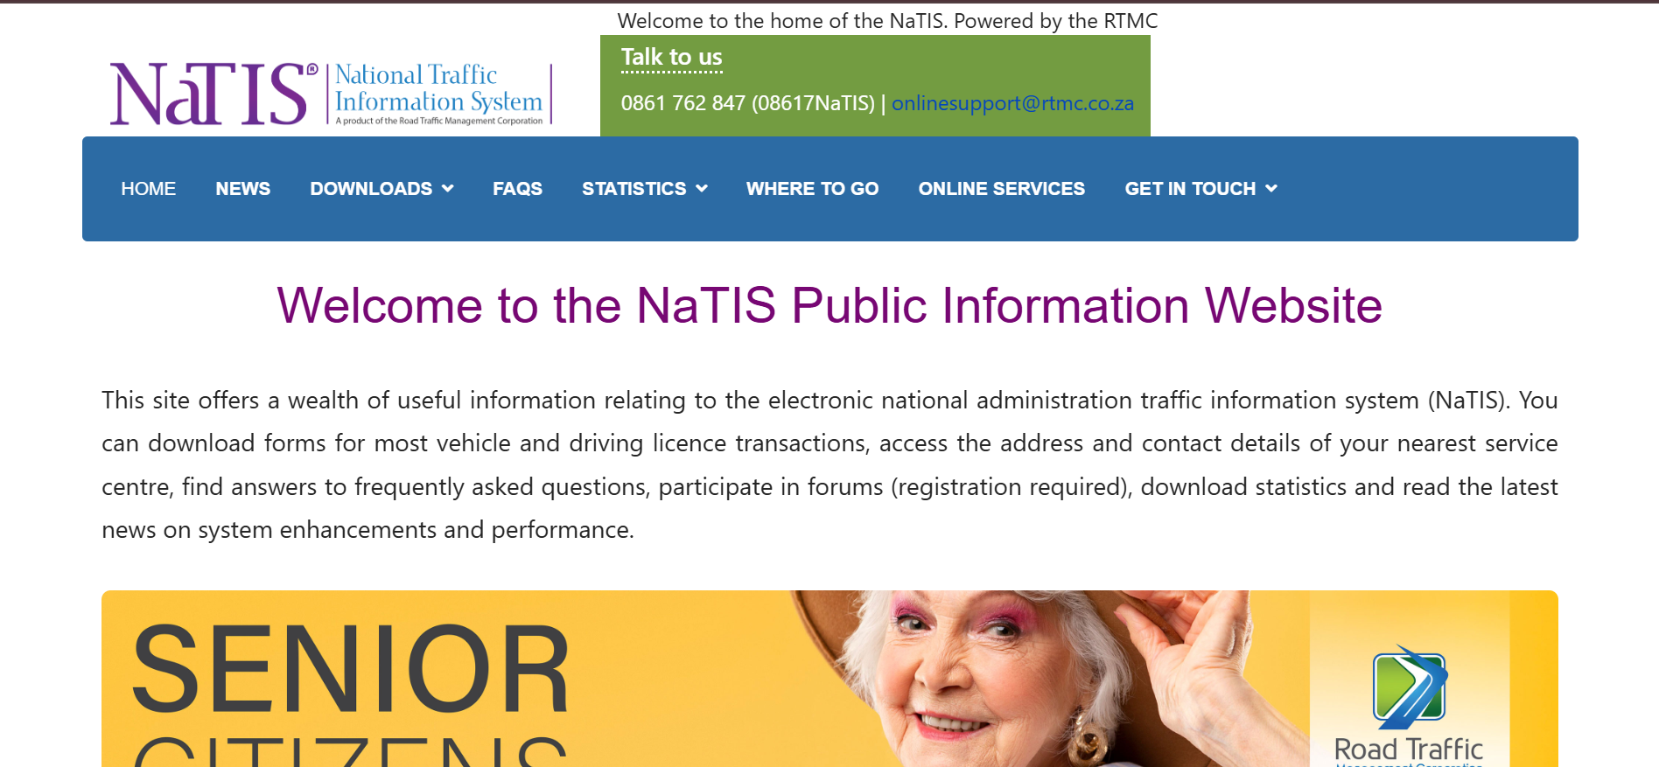
Figure ‎2.2 NaTIS Website

2.4.3 Insurance Regulatory Authority Online Portal (IRA)
As NTSA oversees vehicle and driver matters, another key component of Kenya's compliance landscape lies in the hands of the Insurance Regulatory Authority (IRA). IRA was established by virtue of the Insurance Act (Amendment) 2006, CAP 487 of the Laws of Kenya and is the statutory body that regulates, supervises, and develops the insurance sector (Authority, 2022). The IRA's online platform acts as the electronic interface through which insurance firms, brokers, and agents communicate with the regulator. Although it does not directly provide a compliance mechanism for the owners of motor vehicles, it forms a crucial part of the regulatory framework concerning motor vehicle insurance.
Before the establishment of the portal, IRA faced silent data problems where supervisory data resided in several separate systems; report creation took about six months, and the IRA had to hire around ten extra contract workers each year to handle data collection issues. To overcome this challenge, IRA entered into a RegTech agreement with Regnology, resulting in the development of an Entity Reporting System (ERS), which automates data collection processes, monitors submission dates, identifies overdue reports, and conducts automated analysis of data of insurers. There have been impressive achievements since then, whereby report creation time was reduced from six months to 45 days, and IRA can create risk profiles for all insureds within its jurisdiction without human intervention. This initiative aligns with the IRA's wider strategy towards RBS in accordance with the IAIS guidelines (Authority, 2022).
But seen in light of this research, by far the most serious limitation of the portal becomes evident – it is inward-looking entirely. There is no way for the traffic officer to be able to confirm within the shortest time possible through IRA APIs whether that particular vehicle has an active insurance policy on their name. If a forged document is issued, the certificate will not be identified during the inspection process by the use of IRA systems on the spot. It is clear that while the IRA portal and the NTSA TIMS continue operating from within the silos, that (Onyango, 2022) notes as the major limitation of Kenya’s regulatory systems, Kenya has a system regulating insurance companies, another one managing vehicles, but nothing brings them together
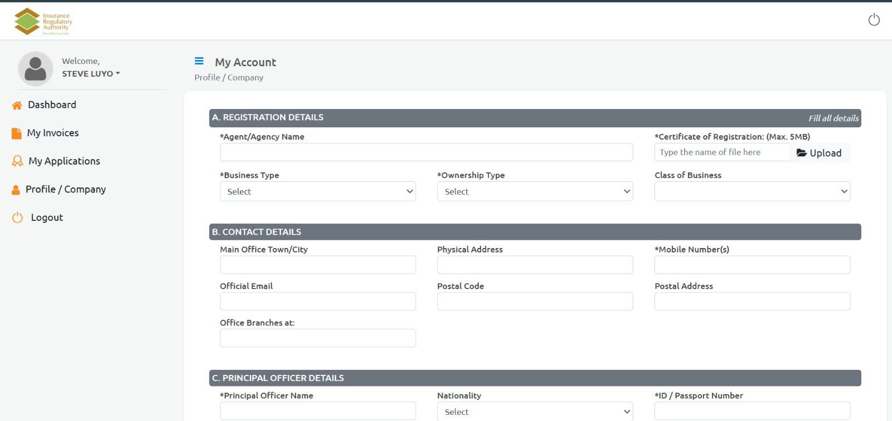
Figure ‎2.3 IRA Dashboard

2.5 Conceptual Framework
The conceptual framework illustrates the overall structure and interaction of the proposed Vehicle Compliance Web Application, showing how users access the system and how data flows from the frontend to the backend and database. The system supports three main actors: enforcement officers, citizens, and the system administrator, each with a specific interface based on their role. Enforcement officers use the plate lookup feature to enter or scan a vehicle number plate and instantly view a compliance dashboard showing the status of insurance, driving license, and vehicle registration, including warnings for records nearing expiry. Citizens access a secure portal where they can register, log in, and view their own vehicle compliance details. The admin uses an admin panel to manage user accounts and update vehicle compliance records. On the backend, API modules handle authentication, plate lookup, vehicle detail retrieval, and record updates, while backend logic validates expiry dates and generates the overall compliance status. All system data is stored in a PostgreSQL database containing tables such as vehicles, licenses, insurance policies, and user accounts. Overall, the framework demonstrates how the system enables real-time verification and management of vehicle compliance through integrated interfaces, backend processing, and centralised data storage.

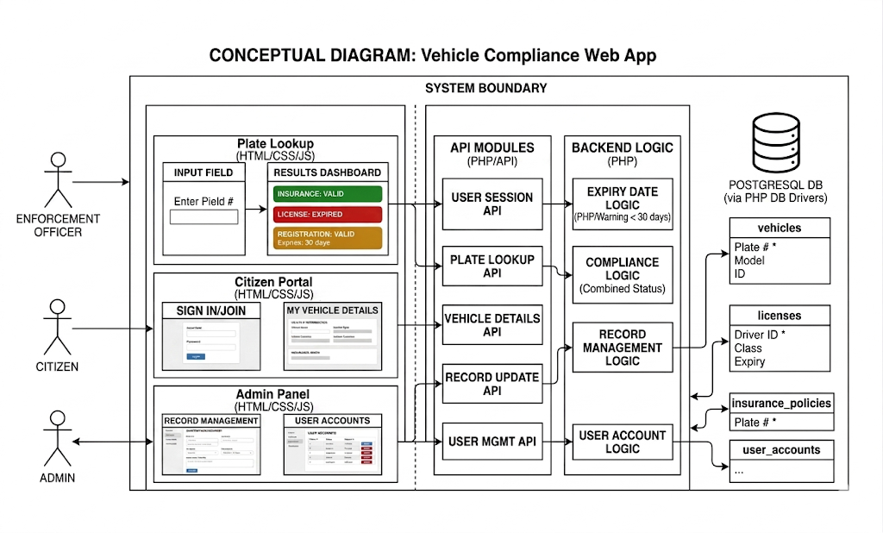
Figure ‎2.4 Conceptual Framework for the Proposed Vehicle Compliance Web Application

Chapter 3: Methodology

Introduction
This chapter shall provide an overview of the Modified Waterfall Model approach that is characterised by its systematic and orderly procedure. It starts with an assessment of the requirements from NTSA reports, Insurance Regulatory Authority materials, the Kenya Traffic Act, and literature on vehicle compliance in Kenya. The analysis and design phase will be executed with object-oriented principles to create OOAD models, including ERD, use case diagram, class diagram, sequence diagram, and the database model. The system will be created using languages such as HTML, CSS, JavaScript, and PHP to create a web-based vehicle compliance verification system. It will incorporate functionalities such as authentication, compliance verification, and user management for users. Testing shall also be done to ensure functionality and usability.

Project Orientation
The suggested system is designed using OOAD because of its inherent modularity and reusability characteristics, which align with the nature of the entities the system operates on. By creating discrete objects such as a vehicle, an insurance policy, and a user, these objects become unique in their own ways; each object is responsible for its own state and behaviours, and acts like a reusable component that optimises functionality within the system. A car object has properties such as its registration number, its owner, and expiry period, and similarly, the insurance object will have its own provider, policyholder, and validity period. The users may be law enforcers, citizens, or administrators, who interact with the system based on their respective rights and responsibilities (Liu, 2022).

Methodology
Waterfall methodology is an established software development technique. In this methodology, there is a sequence of stages like analysis, designing, implementing, testing, and deploying. Unlike agile methodologies, the waterfall methodology emphasises finishing one stage and moving on to the next. This methodology suits projects having definite and consistent requirements since the start (Senarath, 2021). The proposed system of vehicle compliance verification is based on fixed goals and functionality, hence the appropriateness of this methodology to our project. This model is characterised by proper documentation, effective planning, and manageable project management through the whole process of development (Saravanos & Curinga, 2023). All in all, this methodology offers a systematic approach that will enable us to successfully develop this compliance verification system.

Thus, the Modified Waterfall Model will be utilised as the framework for software development of the integrated vehicle compliance verification system. This methodology will involve a sequence of activities, including requirement gathering, design, implementation, testing, and maintenance. However, unlike the regular Waterfall Model, the Modified Waterfall Model will enable feedback between the phases at any time during the process in case any mistakes or inconsistencies occur (Saravanos & Curinga, 2023). The flexibility of the model will be beneficial for improving the reliability of the developed system. It can be applied to this development project since its requirements are fixed and will not change. According to existing research, the Modified Waterfall Model facilitates improved documentation, better control, and better quality of structured software development (Senarath, 2021).

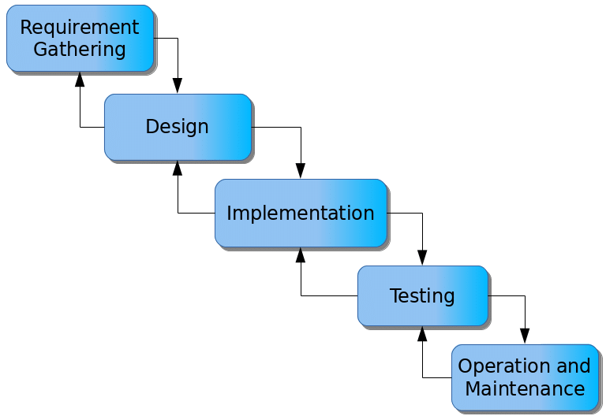
Figure ‎3.1 The Waterfall Model of the Software Development Lifecycle

Requirements Analysis
In order to understand the problem, an evaluation will be made of previous research, government documents, and reports regarding the enforcement of vehicle compliance in Kenya. Secondary data will be sourced from the NTSA reports, Insurance Regulatory Authority reports, and the Kenya Traffic Act. The information collected from these sources will help in finding out the weaknesses in the existing compliance verification process of vehicles. From these weaknesses, the functional and non-functional system requirements will be generated. In order to come up with the functional requirements, use cases will be used. These will cover the interactions among the users, enforcement officers, and the system itself. Additionally, the user stories of the different users will be used in order to identify their needs.

Analysis and Design
The object-oriented methodology that will be used in this study will facilitate the use of modularity, scalability, and reusability in the design of the vehicle compliance verification system. Using OOAD will make it easy to model components such as user authentication, vehicle verification, insurance verification, and license verification. Object-Oriented Analysis and Design Diagrams will be made in order to visualise the working of the proposed system, since these diagrams will enable the organisation of system components and also show the interactions between different objects within the system. Moreover, using these diagrams will enable systematic documentation of system requirements. There are various tools for creating Object-Oriented Analysis and Design Diagrams, some of which will be used in this study, including draw.io.
The following diagrams are going to be constructed for the analysis: a Use Case Diagram depicting interactions between users and the system; a Class Diagram depicting Classes, Attributes, Methods, and Relationships; a Sequence Diagram depicting interactions among system components for compliance verification; an Entity Relationship Diagram depicting relationships between data entities; and a Database Schema Diagram, which will depict database tables as well as fields and relationships between those tables from the ERD. These diagrams are going to give a clear picture of how the proposed system can be implemented.

Development
This proposed system will be a website application which will provide vehicle compliance verification. The application will offer the ability to verify vehicle compliance on the go for enforcement officers and citizens by providing an avenue where the registration, licensing, and insurance status of vehicles can be checked. As a front-end technology for building this website application, HTML and CSS will be considered since they offer the basic structure and style required in creating good-looking and interactive webpages. They will make the navigation of the compliance dashboard by the enforcement officers, citizens, and other site users easy and intuitive. With JavaScript being integrated into the webpages alongside HTML and CSS, dynamic behaviour can also be implemented in the interface.
On the back end, PHP will be used since it is compatible, easy to learn, and appropriate for implementing the server-side logic, which includes authentication of users, handling of compliance records, and interface with the database. By combining these technologies, including HTML, CSS, and JavaScript on the front end and PHP on the back end, a complete web stack will be created, with each component serving a specific purpose in ensuring accuracy of compliance data. In this way, the chosen technologies will not only ensure that the application is easily accessible and interactive in various web browsers, but also enable secure handling of the sensitive information related to vehicles and their drivers on the server side.

Testing
Various tests will be done to guarantee that the system is suitable for its intended use and works consistently with regard to the execution of the compliance verification functions. Unit tests will be done to check whether each part of the system, such as the vehicle registration check functionality, insurance verification functionality, and driver licence verification functionality, among others, operates well independently before integrating them in the whole system. Interface tests will be done to check whether the web-based user interface of the software responds appropriately to the needs of users by checking whether it is responsive and easy to use, and that enforcement officials, citizens, and system administrators have no problems navigating the compliance dashboard. Requirement tests will also be done to check if the final system developed conforms to all the stated requirements..

Deliverables
In regards to the intended web application for vehicle compliance verification, there are several types of documentation, system models, and deliverable products to be expected during the software development and delivery process. The first type of documentation to be expected is the requirement document, the test plan document that will outline the test approach, design document, complete with diagrams, and finally, a user guide document that provides instructions on using the system. In regards to the system model, there are the OOAD diagrams that need to be created. In regards to the deliverable product, there should be a web-based compliance verification system along with a user-friendly interface, a vehicle compliance check system, notifications, user accounts and profiles, security measures, and a scalable infrastructure that allows future integration with NTSA and other databases.
The modules that will be involved in the system will be the user management module, the vehicle registration verification module, the driver license verification module, the insurance verification module, the compliance reporting module, the notification module, and the security and access control module. The users of the system will be the enforcement officer, the citizens, and the administrator. The function of the enforcement officer will be to log in to the system, input the vehicle number plate, and instantly receive information regarding the compliance of the vehicle concerning registration, insurance, and license validity. The function of the citizen will be to log in to the system and obtain the compliance information of their vehicle.

Security and authentication within the system would ensure the safety of the information of both law enforcement officials and civilians, while ensuring that the authorisation process for both parties takes place efficiently.

Chapter 4 System Analysis and Design

Introduction
This chapter has discussed the various components of the system identifying both the functional requirements and the non- functional requirement of the system. These functional requirements have been represented in the form of diagrams, following OOAD approach.

System Requirements
The different functionalities needed for the fulfillment of users' requirements are discussed hereunder as functional and non-functional requirements.

Functional Requirements
The Vehicle Compliance Verification System will have the vehicle owner login via credential verification, the vehicle owner will gain access to their dashboard from which they will have the ability to check on their vehicle registration information, insurance information, license information, and general compliance information, with each piece of information being extracted by the system. In the case that the vehicle owner sees something wrong with any of their compliance information, they will have the ability to submit a correction request, which will be saved for administration review by the system.
The Traffic Enforcement Officer starts the process with logging into the system through credential authentication to access the officer dashboard. After logging in, the officer is allowed manually type in a number plate of the vehicle, whereby after that, the system authenticates the number plate format, pulls the vehicle information records for that particular number plate, and shows the details of the vehicle, including its insurance status, licence status, compliance outcome, and a roadside report, which will be stored in the system as vehicle query, compliance verification, and roadside report records. The officer is granted read-only privileges and is not allowed to create, change, or edit any compliance record.
The System Administrator accesses the administrator’s dashboard via credential authentication. This is where all activities within the system are controlled and managed by the system administrator. The creation and management of compliance information for vehicles, as well as registration of vehicles, assignment of ownership of vehicles to citizens who are registered in the system, and update of vehicle’s license, insurance, and registration details fall under the responsibility of the administrator alone; the vehicle owner and the enforcement officers are not allowed to carry out these operations. New user accounts can be created by the system administrator and already existing ones deleted; accounts can also be assigned particular roles by setting up their permissions in the system; each of these actions is recorded in the system.

Non-Functional Requirements
Security will be facilitated through credential validation, role-based access control, password encryption, and log auditing, in order to keep sensitive information regarding the vehicles and users secure and only accessible to those who have authorization for the same. It should not be possible for the owner of a particular car to see the information on another car owned by someone else, and similarly, it should not be possible for an enforcement officer to make changes to the compliance information.
The reliability factor shall be assured by conducting input validation tests, error handling procedures, and storing backups. The consistency factor will be ensured because the system must provide consistent output whenever it is used for whatever purpose, such as when an enforcement officer obtains a compliance result at a roadside check or an administrator makes changes to the record of a particular vehicle.
Availability shall be made possible via the implementation of the system as a web application which will be accessed via regular browsers and thus enable law enforcement officers, vehicle owners, and administrators to access the portal at any convenient moment and without needing specialized devices or installations. It becomes especially important for law enforcement officers who need real-time data on compliance.
Usability will be taken care of by using user-friendly interfaces based on role-based dashboards that are tailored to the individual user’s requirements, making it easy for an enforcement officer to get a compliance decision rapidly at a road side check point, for the car owner to see his compliance results clearly, and for the administrator to maintain record easily without having to go through any hassle.
Maintainability will be achieved using the modular OOAD design that will consist of different elements of the system, enabling the system developers to make changes to some modules without causing any disruptions to the operational system. Through the use of different elements like cars, insurances, licenses, and user accounts, all components of the system will be able to undergo modifications.
Integrity of data will be achieved using validation of data input, approval processes for correcting errors in records, and permission to make updates limited to the administrator. Data in the system relating to compliance records will therefore be accurate and not subject to manipulation. Mandatory fields containing empty information, non-compliance with plate number format, and date format will automatically be flagged and not entered into the database.

System Analysis Diagrams
These diagrams show how the system meets its requirements. The list of diagrams includes use cases diagrams, sequence diagrams, database schemas, ER diagrams, class diagrams, and wireframe diagrams. Each diagram gives an illustration of various parts of the system's work. These diagrams allow gaining insight into the system's behavior, structure, and interaction.

Use Case
The Use Case Diagram helps define the functional scope and boundaries of the Web-Based Vehicle Compliance System, which shows the actual interaction between the external actors and the internal processes within the system. Three major external actors include the Vehicle Owner, the Traffic Enforcement Officer, and the System Administrator.
The Vehicle Owner uses functionalities that center around self-compliance check, where he/she can create account(s), view his/her vehicle collection(s), see localized status (insurance, license, registration, service history), and submit corrections. The Traffic Enforcement Officer uses functionalities such as mobility or roadside functionalities, where he can search for vehicles based on their plate number, analyze real-time dashboard compliance, and also generate roadside report(s). Both roles depend largely on functionalities in the core that provide validation of compliance status such as authentication, session management, and background calculation of compliance thresholds.
On the other hand, the System Administrator has full control over the environment of the application. This participant performs wide back-end usage scenarios, including user accounts administration, assignment of single vehicle ownership, changes to records for all compliance components (insurance, license, registration, and service), and notification configuration.
The cross-cutting functionality of the system, including creation of multi-channel automated alerts (In-App, SMS, Email notifications), is designed according to analytical dependencies, that is, initiated based on either status calculations or road-side log and correction parameter demands.

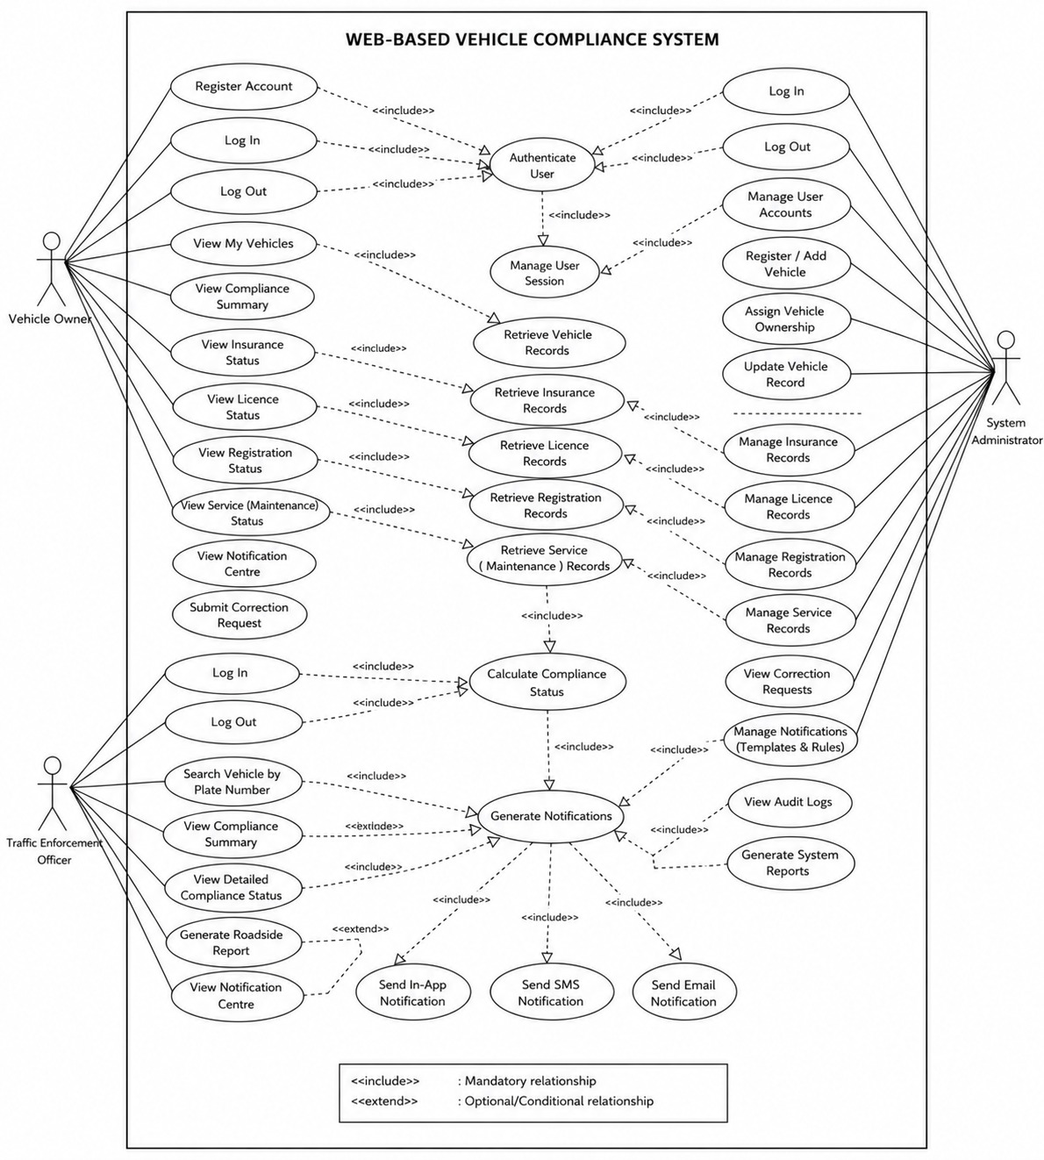
Figure ‎4.1 Use Case Diagram for the Web-Based Vehicle Compliance System

Sequence Diagram
Sequence diagrams capture the dynamics of the system, capturing the manner in which messages, method calls, and payload data transfer synchronously move through time on the User Interface (UI), system microservices, and the central database storage level.

4.3.2.1 Sequence Diagram: Vehicle Owner Interactions
The Vehicle Owner lifecycle shows the time series process flow for user authentication, asset validation, and data updates. The process starts when the owner logs in or registers using the Web Application UI. Then, the UI sends a synchronous call to the Authentication Service to validate credentials against the Database, generating an encryption/validation token.
When a valid session is created, the process diverges based on logical fragments. In a valid session, calling for vehicle dashboard performs local search up to the Compliance Service, which searches for profile matches in the database and returns the whole list to the UI wrapper.
Selection of a specific vehicle results in performing an internal logic loop for absolute compliance calculation, which requires searching distributed database schemas one after another – insurance information, license validation, registration files, service stamps. When all processes complete successfully, the Compliance Service sends back visual parts of the information.
Optional logic fragments (opt) are applied if some conflicts arise – then the user sends update request directly mapped via Compliance Service to the Database, and if notifications are requested, the target is sought out in the database by means of the Notification Service, switching tracking status into ‘Read’.

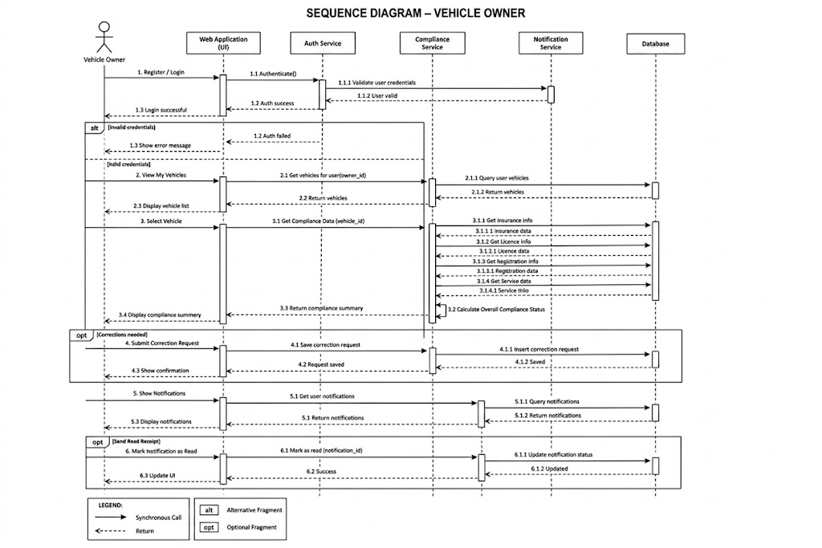
Figure ‎4.2 Sequence Diagram for Vehicle Owner Interaction Flow

4.3.2.2 Sequence Diagram: Traffic Enforcement Officer Interactions
The Traffic Enforcement Officer process reflects the design of quick search and queries processes intended for real-time field implementation. The process starts with the authentication process that verifies the identity of the traffic officer via the authentication server. Having access approved to field work, the workflow focuses on conducting immediate field searches.
On entering a car registration number by the officer or by scanning it, the Web application sends a corresponding field query request to the Compliance Service that performs a quick index query in the database confirming the presence of this car. Upon its validation, the next step includes a payload query that retrieves insurance data, types of driving licenses, registration status, and vehicle maintenance records. All this information about the compliance of the car is sent immediately to the user interface.
The final stage of the process is represented by the creation of reports. The traffic officer initiates creation of the roadside report that triggers formatting and storage of the data snapshot from the compliance service to the database.
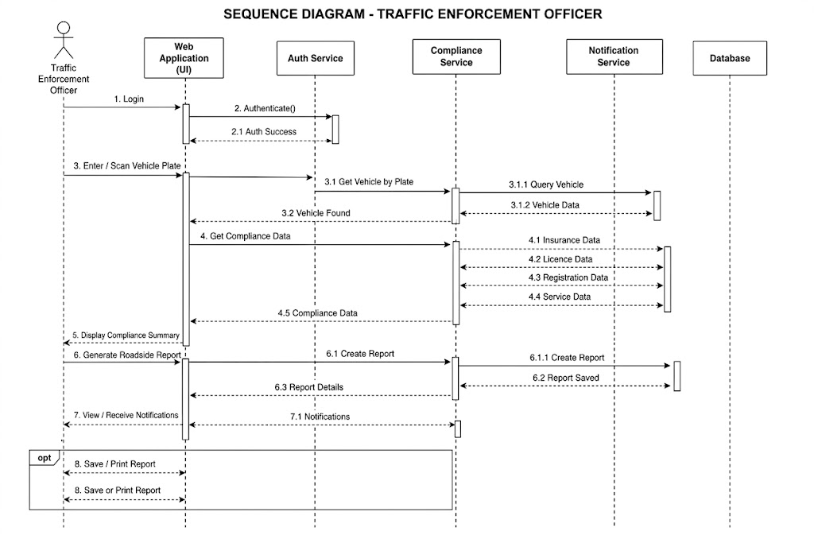
Figure ‎4.3 Sequence Diagram for Traffic Enforcement Officer Field Queries

4.3.2.3 Sequence Diagram: System Administrator Interactions
Administrative Procedure, Platform Modification, and System Audit Tracing are described in the System Administrator process. After the administrative login is made using the authentication protocol, this process records separate modifications and administration procedures.
In case the administrator changes the essential elements of the system, for example, by editing the information on cars, drivers' licenses, or registering them, the UI passes this information via the Admin Service, which then makes the required structural modifications (CRUD operations) in the appropriate tables of the database.
All user management procedures (activation, modification, and deactivation) go through the same procedure in the background administrative interfaces. All messaging procedures are executed as follows: the administrator changes the settings and rules in the Notification Service, which automatically saves all changes to storage files.
Finally, the System Administrator process involves security-related procedures and system diagnosis procedures: the administrator receives raw audit logs or performance graphs that compel the Admin Service to analyze all event logging tables in the database and generate a report.
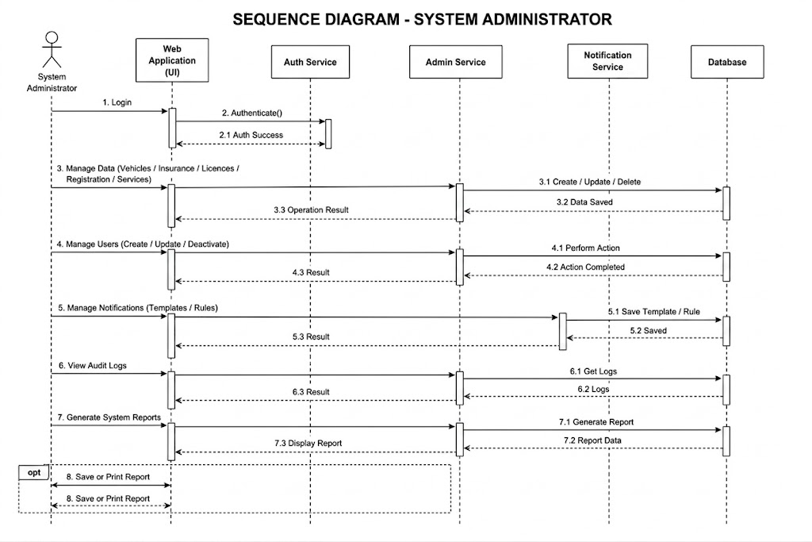
Figure ‎4.4 Sequence Diagram for System Administrator Operational Workflows

Entity Relationship Diagram
It will highlight the relationships that exist among different entities within the database of the system. The diagram will outline how the users such as Vehicle Owner, Traffic enforcement officier, and system Administrators use the system and share information in this context. The relationships that exist between other vital entities like vehicle, notifications, and compliance record can be highlighted in this way. For instance, it can highlight the relationship between Vehicle Owner and vehicle, or the relationship between Traffic enforcement officier and compliance record.
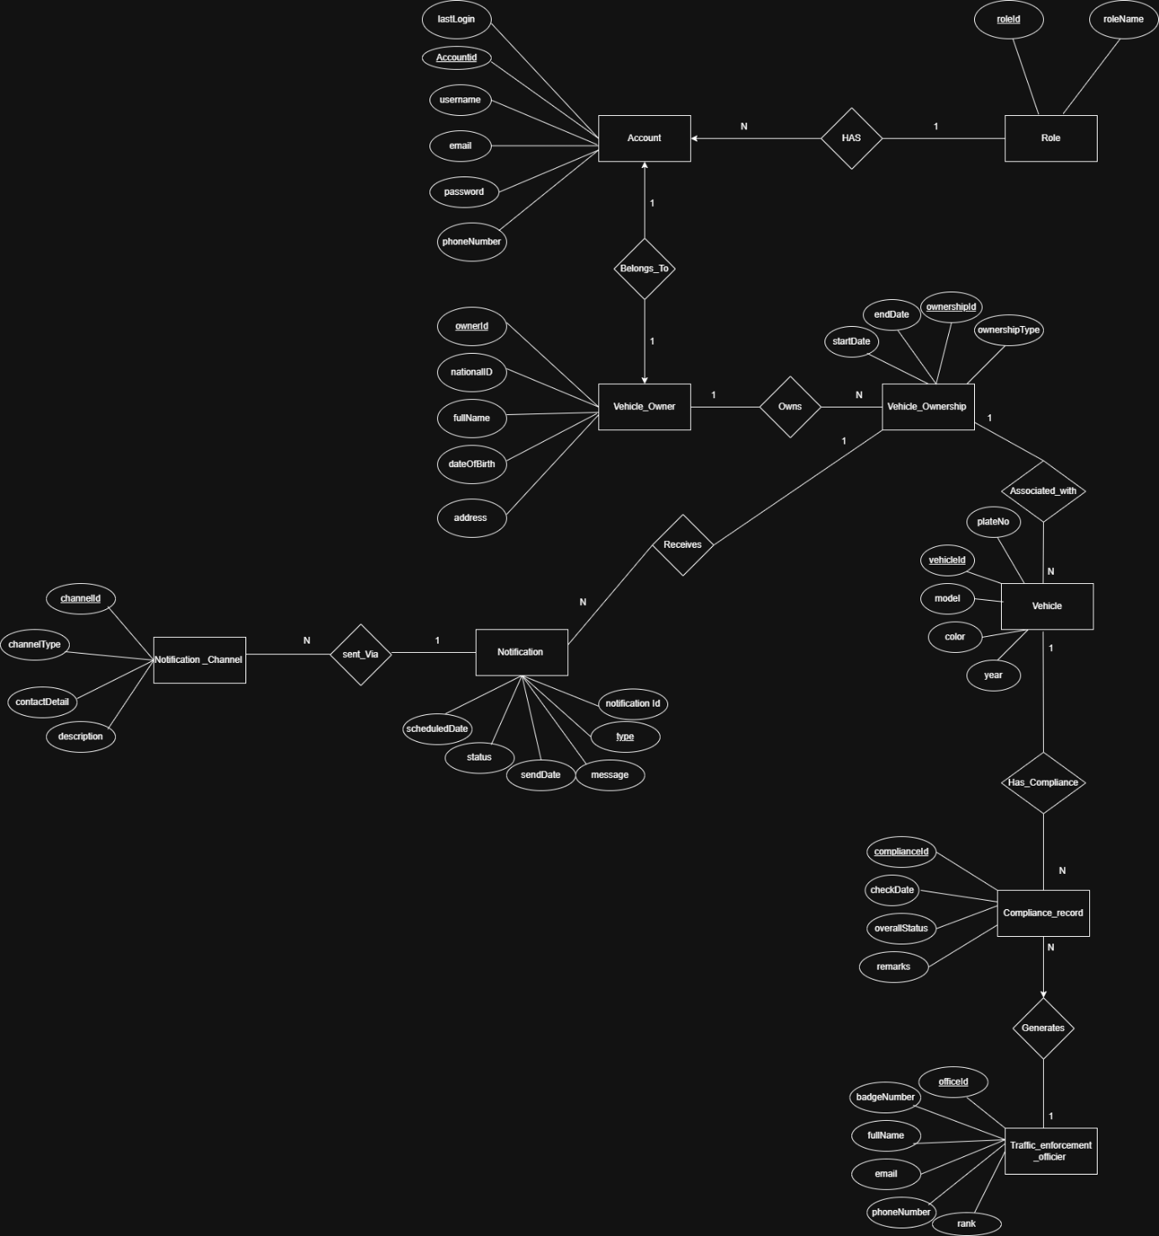
Figure ‎4.5 Entity Relationship Diagram (ERD) for the Vehicle Compliance System

Class Diagram
The class diagram presented below represents a centralized Vehicle and Traffic Compliance Management System for monitoring vehicles, ownership information, insurance details, and driver’s license. The system implements an access control model based on inheritance, where an Account class is derived to represent user categories such as the Vehicle Owner that keeps track of vehicle status and notifications; Traffic Enforcement Officer that checks vehicles and creates roadside reports; and the System Administrator that creates accounts and manages system reports. The relationship between various users with key classes like vehicle, insurance policy, and driverLicense allows the mapping of individual information for determining the centralized “ComplianceRecord.” 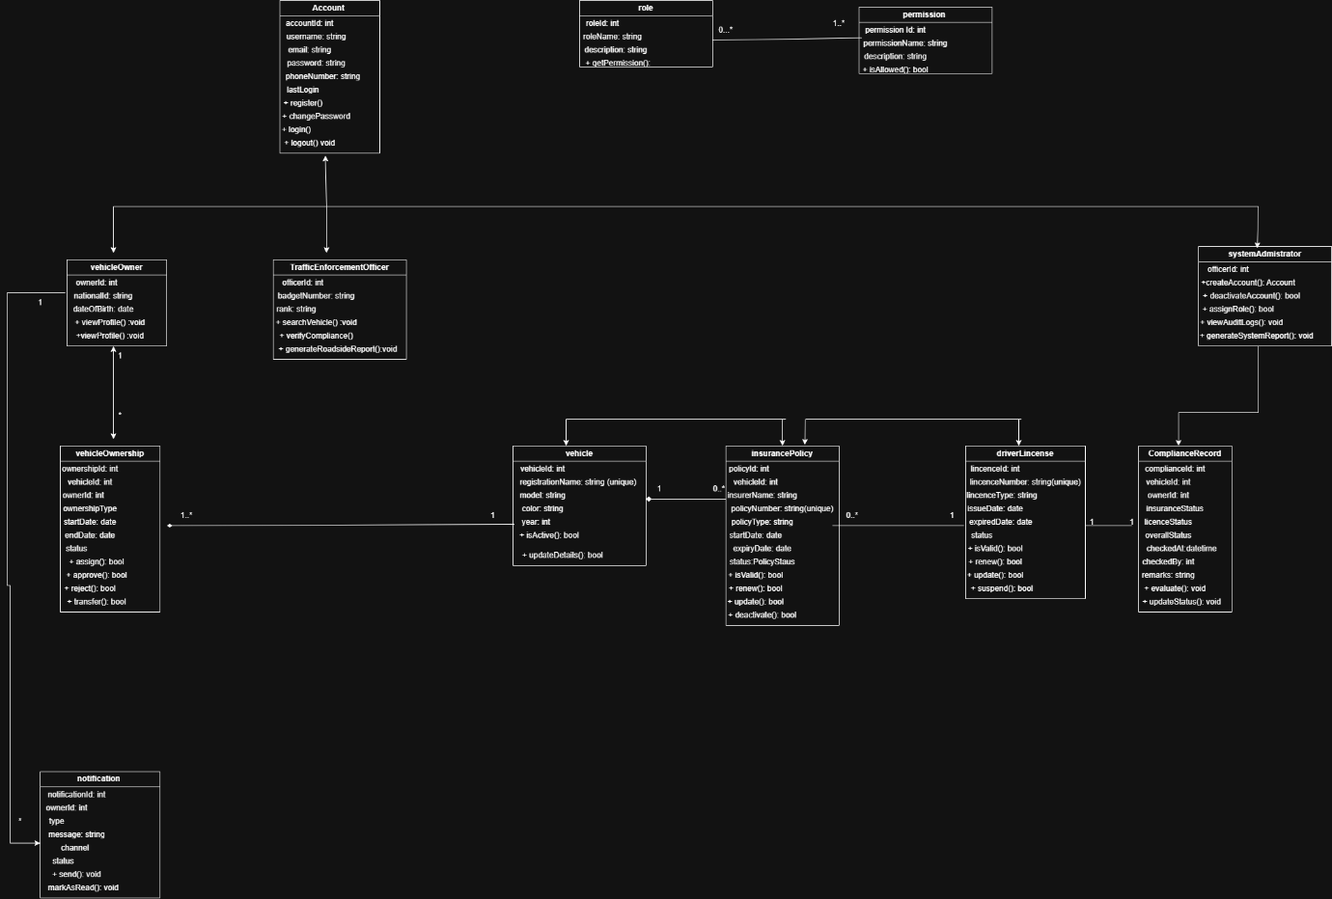
Figure ‎4.6 Class Diagram for the Vehicle Compliance Web Application

Database Schema
The architectural structure of the Persistent Data Store is defined using a Relational Database Schema Diagram, categorizing data into normalized and highly decoupled relational tables that guarantee data integrity, avoid redundancy and establish relationships between data.
Users table serves as the main authenticating directory that contains encrypted passwords for authentication, contacts, role assignment (owner, officer or admin) and status information about the profile. The users table connects directly to an element of security logging, named audit_logs, for the sequence logging of transactions and changes made to the system.
Asset tracking is done through a vehicles table mapped into a one-to-many relationship to a specific profile of the owner from the users collection. From the vehicles table, there are sub-tables that are independently structured to manage different compliance issues:
• insurance_policies: Holds information regarding policy validation, types of coverages and expiry dates, all with the help of index keys related to each individual policy associated to vehicle.
• licences: Contains details about drivers' criteria and restrictions and links back to citizen identification details.
• registrations: Contains registration details of vehicle, tracking number and validity period.
• services: Manages the maintenance schedule, odometer readings of vehicle and services required on time.
Processing in real time will use the compliance_records table, which serves as an aggregation table that merges information on real-time processing scores from the insurance, license, registration, and services states to obtain the aggregate real-time assessment scores. The compliance_records table is also connected to the roadside_reports table to report any real-time field queries made by traffic police officers.
The communications within the system can be facilitated through the notifications table, which links to the notification_channels and compliance_statuses tables in the references tables category.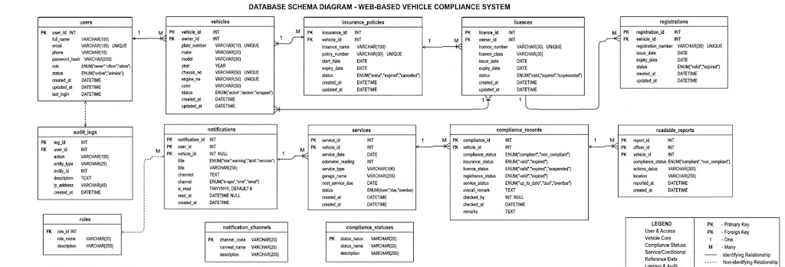
Figure ‎4.7 Database Schema for the Vehicle Compliance Web System

Wireframe Diagram
This demonstrates a good example of the application interface's visualization, which will help designers and other people involved understand how the elements are organized on the screens.

Figure ‎4.8 Wireframe Diagram

Chapter 5: Development and Testing

5.1 Introduction
This chapter presents the development and testing of the web-based vehicle compliance system. It explains how the ideas developed in the analysis and design chapter were translated into a working application, how the solution supports real-time compliance verification, and how the final build was checked against the stated requirements.
The discussion also shows the implementation environment, the major system modules, the main challenges encountered during development, and the tests used to verify that the software meets the intended functional and non-functional requirements. The screenshots that support the implementation and test discussion are organised in the appendices and referenced throughout this chapter.

5.2 Setup Description
The system was developed as a modular web application so that the presentation layer, business logic, and database layer could be managed separately. This structure made it easier to debug individual functions, reuse shared routines such as validation and authentication, and prepare the project for future scaling or integration.

5.2.1 Technical Stack and Environment
Table 5.1 Development and Testing Environment
Hardware environment | Laptop-class Windows workstation with enough processing power and memory to run the local server, browser, and database concurrently.
Operating system | Windows-based development environment.
Web server | Apache through XAMPP.
Backend language | PHP.
Front-end technologies | HTML, CSS, and JavaScript.
Database management system | MySQL.
IDE | Visual Studio Code.
Version control | Git and GitHub.
Testing browser | Google Chrome.
Backup strategy | Periodic SQL exports and repository backups kept separately from the working files.
Using a controlled local development stack supported clear separation of concerns. The front end handled user interaction, PHP processed business rules, and MySQL stored the relational data required for vehicle, user, and compliance records. This arrangement supported modularity, improved maintainability, and allowed the system to be tested safely before any deployment-oriented work.

5.2.2 Implementation Overview
The implemented system centres on four core modules: authentication, vehicle record management, compliance verification, and reporting. The authentication module controls access to the system, while the vehicle module stores ownership and compliance-related records. The compliance module aggregates the status of the vehicle, insurance, licence, registration, and service information to produce a single compliance result. The reporting module summarises the records for administrative review and decision support.
The implementation follows the use case, sequence, ERD, and class diagrams in Chapter 4. For example, the compliance check begins when a user submits a vehicle number plate, after which the application retrieves the associated records and calculates the overall compliance status. This flow preserves the logic described in the design chapter and keeps the final solution aligned with the original scope.

5.2.3 Stakeholder Interaction and Functional Fulfilment
The three primary stakeholder groups defined in the proposal were supported through role-based interfaces. Vehicle owners can register, sign in, and review the compliance status of their vehicles. Traffic enforcement officers can search by number plate and view the current compliance position during roadside checks. System administrators can manage user accounts, maintain records, and review system outputs.
These role-specific views reduce confusion because each user sees only the actions relevant to their responsibility. The result is a simpler workflow for the public, faster verification for enforcement officers, and better administrative control for the system owner.

5.2.4 Non-Functional Requirement Realisation
The non-functional requirements were addressed through a combination of interface design, validation rules, and data management practices. Security was improved through password-based authentication and access control, while usability was supported by clear labels, simple navigation, and a responsive layout that adapts to different screen sizes. Reliability was strengthened through input validation, database constraints, and consistent error messages.
Maintainability and future scalability were also considered. The codebase was organised into logical modules so that changes to one function would not require rewriting the whole application. Likewise, the use of a relational database makes it easier to extend the system later by adding new tables or integrating external services without disturbing the existing core logic.

5.2.5 Logic Consistency and Traceability
A key implementation objective was to ensure that no new business process was introduced beyond those already captured in the analysis and design diagrams. The final system therefore follows the same flow shown in the use case and sequence diagrams: authenticate the user, retrieve the relevant vehicle records, evaluate compliance, and present the result. Where the implementation needed extra detail, such as validation feedback or permission checks, the additions were technical safeguards rather than new business processes.
Traceability can be seen in the vehicle compliance check requirement. The use case in Chapter 4 leads to the compliance module in the implementation, and the same function is exercised in the test case table later in this chapter. The supporting screenshots for the implementation and the test evidence are provided in the appendices, especially Appendix A1 to Appendix A6.

5.2.6 Implementation Challenges and Deviations
Several practical issues emerged during development. Inconsistent sample data required repeated validation checks, and some interface components needed refinement to improve readability on smaller screens. These issues were addressed by tightening validation rules, improving the page layout, and separating repeated logic into reusable functions.
A further deviation from the proposal was the absence of live integration with external regulatory or insurance APIs during the project period. For that reason, the final build uses internally managed compliance records for demonstration and testing, while keeping the architecture open for future API integration, automated notifications, and extended reporting.

5.3 Testing
Testing was carried out to verify that the developed system behaves as designed and to validate that it is fit for the intended users. The process combined manual functional testing with interface checks and data validation tests. Each feature was exercised with both valid and invalid inputs so that the system response could be compared with the expected result.

5.3.1 Testing Approach
The tests were conducted manually through the browser against the local XAMPP server. Manual testing was suitable because the project is a web-based application whose behaviour can be observed directly through user actions such as login, search, record creation, and report generation. This approach also made it easy to confirm that the application response matched the intended user workflow.

5.3.2 Test Environment and Tools
The main tools used for testing were Apache and PHP through XAMPP, MySQL for the database, Visual Studio Code for code inspection, and Google Chrome for browser-based verification. phpMyAdmin was used to review database records during testing, while SQL exports were used to preserve working copies of the data. These tools made it possible to repeat tests consistently and to trace the effect of each action on the underlying database tables.

5.3.3 Summary of Test Cases
Table 5.2 Functional Test Case Summary
TC | Functionality | Test data | Expected result | Actual result | Status/Evidence
TC 5.1 | User login | Valid username and password | User is authenticated and redirected to the dashboard. | Login completed and the dashboard opened correctly. | Pass. Appendix A1
TC 5.2 | Invalid login | Registered username with wrong password | System rejects access and shows an error message. | Access was denied and the validation message appeared. | Pass. Appendix A2
TC 5.3 | Vehicle record entry | Vehicle details, registration number, and owner information | Record is saved and appears in the vehicle list. | Vehicle record saved successfully. | Pass. Appendix A3
TC 5.4 | Compliance verification | Valid vehicle number plate | System retrieves vehicle, insurance, licence, registration, and service status, then displays compliance outcome. | Compliance status displayed correctly. | Pass. Appendix A4
TC 5.5 | Report generation | Sample compliance dataset | System produces a summary report with status counts. | Report generated successfully. | Pass. Appendix A5
TC 5.6 | Role-based access control | Attempt to open an admin page using a non-admin account | Restricted page is blocked and the user is returned to an allowed view. | Access was blocked as expected. | Pass. Appendix A6
All the core functional tests passed in the final build. The detailed screenshots for these cases are grouped in Appendix A1 to Appendix A6 so that the evidence can be checked alongside the written results.

Chapter 6: Conclusions and Recommendations

6.1 Conclusion
The project addressed the challenge of fragmented and largely manual vehicle compliance checking by developing a single web-based platform for storing and verifying compliance records. The final system brings together the information needed for vehicle registration, insurance, licence, and service verification so that users can obtain a clearer and faster compliance outcome.
The practical outcome of the project is that centralised storage and rule-based verification reduce the chance of human error and make compliance checking more orderly. This confirms the main assumption behind the proposal: when the relevant records are managed within one system, both citizens and enforcement officers can make quicker and more consistent decisions.
The project objectives set in Chapter 1 were also achieved at the implementation level. The system provides authenticated access, supports record management, performs compliance checks, and generates reports for decision support. Compared with the silo-based solutions reviewed in Chapter 2, the developed application offers a single interface that combines the compliance information needed for operational use, even though full external integration remains a future enhancement.
The Modified Waterfall approach was effective for this work because it allowed each phase to be completed in a clear order while still permitting correction when issues were discovered during implementation and testing. The main limitations were the absence of live API integration with external regulatory systems and the limited project-time scope for advanced notification features. Despite these constraints, the project delivers a useful contribution to road safety administration by improving the organisation, traceability, and accessibility of compliance information.

6.2 Recommendations
First, future versions of the system should be integrated with official external data sources such as NTSA, insurance providers, and service centres so that compliance records can be updated automatically in real time.
Second, the notification module should be extended to support SMS and email reminders for expiring insurance, licences, registrations, and service dates. This would improve user compliance and reduce late renewals.
Third, the system should be deployed with stronger security and monitoring features, including audit logs, multi-factor authentication for privileged users, and regular backup automation to protect the stored records.
Finally, further research should be carried out on performance testing, mobile-friendly deployment, and predictive analytics so that the platform can support larger datasets and give decision-makers more actionable insight.

References:

2024 year of carnage as 4,700 killed on roads. (n.d.). Retrieved April 27, 2026, from https://the-star.co.ke/news/realtime/2025-01-24-2024-year-of-carnage-as-4700-killed-on-roads
Adisa, A. O., & Eludiora, S. I. (2021). An improved vehicle registration and licensing system. FUOYE Journal of Engineering and Technology, 6(1), 21–25.
Alotaibi, H., Aljeaid, D., & Alharbi, A. (2023). Usability Testing of Memorable Word in Security Enhancing in e-Government and e-Financial Systems. International Journal of Advanced Computer Science and Applications, 14(9). https://www.researchgate.net/profile/Hanan-Alotaibi-3/publication/374492816_Usability_Testing_of_Memorable_Word_in_Security_Enhancing_in_e-Government_and_e-Financial_Systems/links/667e603f0a25e27fbc10e497/Usability-Testing-of-Memorable-Word-in-Security-Enhancing-in-e-Government-and-e-Financial-Systems.pdf
Atianashie Miracle, A. (2023). The Application of Computer in Motor Vehicle Registration over Manual System. Int. J. Sci. Res. in Computer Science and Engineering Vol, 11(2). https://www.researchgate.net/profile/Atianashie-A/publication/370591775_The_Application_of_Computer_in_Motor_Vehicle_Registration_over_Manual_System/links/6457dfb997449a0e1a82325a/The-Application-of-Computer-in-Motor-Vehicle-Registration-over-Manual-System.pdf
Authority, I. R. (2022). Insurance Regulatory Authority. https://www.claims.co.ke/wp-content/uploads/2024/11/quarter1-2024-claims-report.pdf
Demerit System, AARTO and Driver Behaviour. (n.d.). Arrive Alive. Retrieved May 4, 2026, from https://www.arrivealive.mobi/Demerit-System
Global status report on road safety 2023. (n.d.). Retrieved April 22, 2026, from https://www.who.int/teams/social-determinants-of-health/safety-and-mobility/global-status-report-on-road-safety-2023
Karoki, G. N., Nyamari, J. M., & Gachoki, P. K. (2025). Road Safety Knowledge and Practices amongst Pedestrians on Thika Super Highway, Nairobi County. https://repository.kyu.ac.ke/handle/123456789/1167
Kodiyatar, N., & Shamala, A. (n.d.). Research Proposal: Development and Implementation of a Mandatory Digital Driver Licence (DDL) System for Enhanced Road Safety and Accountability. Retrieved May 4, 2026, from https://www.researchgate.net/profile/Nohil-Kodiyatar-2/publication/396702634_Research_Proposal_Development_and_Implementation_of_a_Mandatory_Digital_Driver_Licence_DDL_System_for_Enhanced_Road_Safety_and_Accountability/links/68f63ad5f3032e2b4beabc21/Research-Proposal-Development-and-Implementation-of-a-Mandatory-Digital-Driver-Licence-DDL-System-for-Enhanced-Road-Safety-and-Accountability.pdf
Liu, W. (2022). The Implications of Object-Oriented Analysis and Design. Global Journal of Engineering, Design & Technology, 11(3), 1–2. https://doi.org/10.35248/2319-7293.22.11.157
Muguro, J. K., Njeri, P. W., & Sasaki, M. (2024). Public transportation in Kenya (A Phenomenological study of transport issues). Bentham Science Publishers. https://books.google.com/books?hl=en&lr=&id=2SQdEQAAQBAJ&oi=fnd&pg=PP1&dq=NTSA+transport+integrated+management+system+Kenya+2024&ots=x0utX6fAS9&sig=Gsc7jUmhzGVFiz-zx52uFwg8eq0
Onyango, G. (2022). Police Corruption at Traffic Checkpoints and Roadblocks in Kenya. In Policing and the Rule of Law in Sub-Saharan Africa (pp. 31–49). Routledge. https://www.taylorfrancis.com/chapters/edit/10.4324/9781003148395-4/police-corruption-traffic-checkpoints-roadblocks-kenya-gedion-onyango
Organization, W. H. (2023). Global status report on road safety 2023: Summary. World Health Organization.
SABS Website. (n.d.). Retrieved May 4, 2026, from https://www.sabs.co.za/
Saravanos, A., & Curinga, M. X. (2023). Simulating the software development lifecycle: The waterfall model. Applied System Innovation, 6(6), 108.
Sayed, A., & Patel, M. O. S. (2023). The Influence of JavaScript, on Website Development and User Experience. International Journal for Research in Applied Science and Engineering Technology, 11(11), 87–88.
Segui-Gomez, M., Luo, F., Tingvall, C., & Taylor, M. P. (2025). Assessing the impact of the WHO global status reports on road safety. Injury Prevention, 31(Suppl 1), i1–i6.
Senarath, U. S. (2021). Waterfall methodology, prototyping and agile development. No. June. https://www.researchgate.net/profile/Udesh-S-Senarath/publication/353324450_Waterfall_Methodology_Prototyping_and_Agile_Development/links/60f41f71fb568a7098b9d035/Waterfall-Methodology-Prototyping-and-Agile-Development.pdf
Terefe, B., Jembere, M., & Liyew, B. (2025). Road traffic accidents and its determinants among Kenyan households: Analysis of the 2022 national health survey using multilevel modeling. BMC Public Health, 25. https://doi.org/10.1186/s12889-025-23605-3
Towers, A. (2024). Addressing road safety challenges. International Journal of Health Promotion and Education, 62(6), 647–648. https://doi.org/10.1080/14635240.2024.2426427
Wagle, M., & Dahal, K. R. (2025). International Journal of Multidisciplinary and Innovative Research. https://ijmir.com/v2i9/Doc/3.pdf
Wamwea, C. N. (2023). Influence of transport sector reforms on performance of public transport sector, a case study of Nairobi city county. https://repository.mut.ac.ke/xmlui/handle/123456789/6565
World Development Report 2020: Trading for development in the age of global value chains (World Development Report 2020). (2020). World Bank. https://digitallibrary.un.org/record/3850531
Zhong, Q., Zhang, G., & Tan, Y. (2025). Analysis of Accidents and Casualties due to Unlicensed Driving Offence. CICTP 2025, 1040–1049. https://doi.org/10.1061/9780784486269.099

